Find out what is postman

Install

Crud in php?

Set up new git project

Clone it with git acc

Test commit

No need to branch off since Im the only one working there, otherwise every new feature gets new branch->pull->work->commit->check for updates (checkout to the origin branch->pull->switch to your branch->rebase the origin)->push changes->go to bitbuchet and create a merge request->someone will check and approve work or you need to do a merge too.

Reading about postman API and how it works.

Reading tutorials of how to connect APIs

Watching video!

Crafted little call.php file. It gives some responses back yooaaahhh

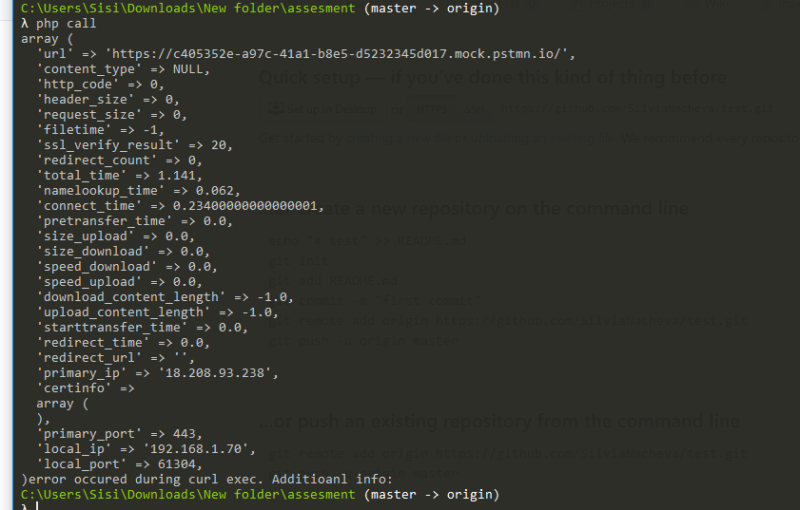

Created a php object to handle requests.

Created methods needed to handle a get request

Added an import to the other call php file.

Stuck… ☹